**CS311 Term Project Configuration Document**

|  |  |
| --- | --- |
| **Project:** | File Compression Tool |

**Programming Languages, Tools and software(IDEs) used for Project implementation:**

|  |  |  |  |
| --- | --- | --- | --- |
| Sr. No. | Software | Version | Reason |
| 1 | Visual studio software with C#,.net framework | 2019 | We Used C# .net framework language for backend and front end to make window form interface |
| 2 |  |  |  |
| 3 |  |  |  |
| 4 |  |  |  |
| 5 |  |  |  |
| 6 |  |  |  |
| 7 |  |  |  |
| 8 |  |  |  |
| 9 |  |  |  |
| 10 |  |  |  |

**Project Configuration Guidelines(Step by Step):**

1. **Step 1**

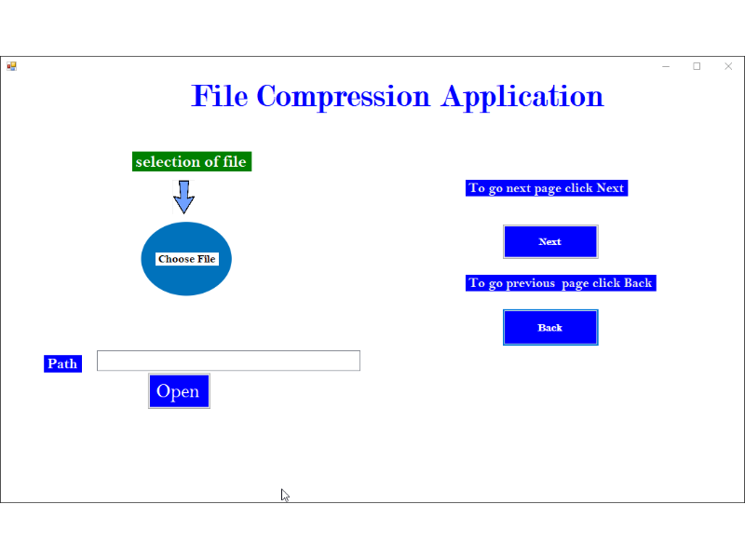

**Selection of interface:**

**Description:**

In this interface we select file which need to be compressed by clicking on button open there will open all folder then select txt file .in text box there show path of selected file.

1. **step 2**

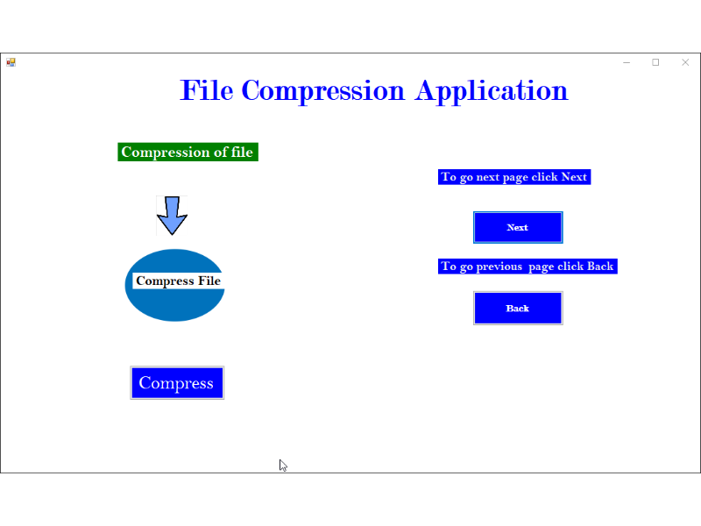

**Compression of file:**

**Description:**

In this interface we compress the selected file by clicking on compress button .in compress button many functionalities has been done like printfrequency, BuildTree, setHuffcode, ASCII, FileWrite, PrintCode, HuffTree, CompressFile or Extension.

**3** **.step 3**

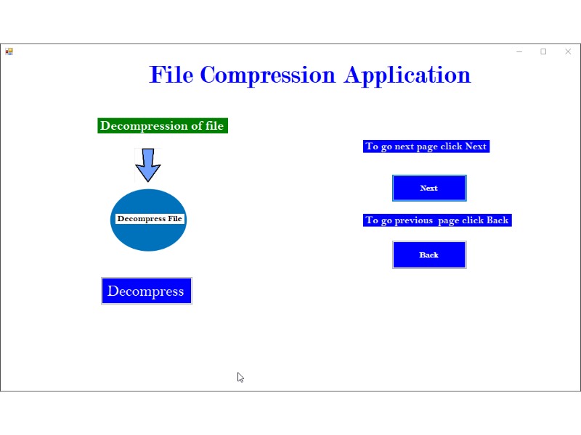

**Decompression of file:**

**Description:**

In this interface after selection of file, compression of file is done now compressed file is decompress by clicking on decompress button

1. **step 4**

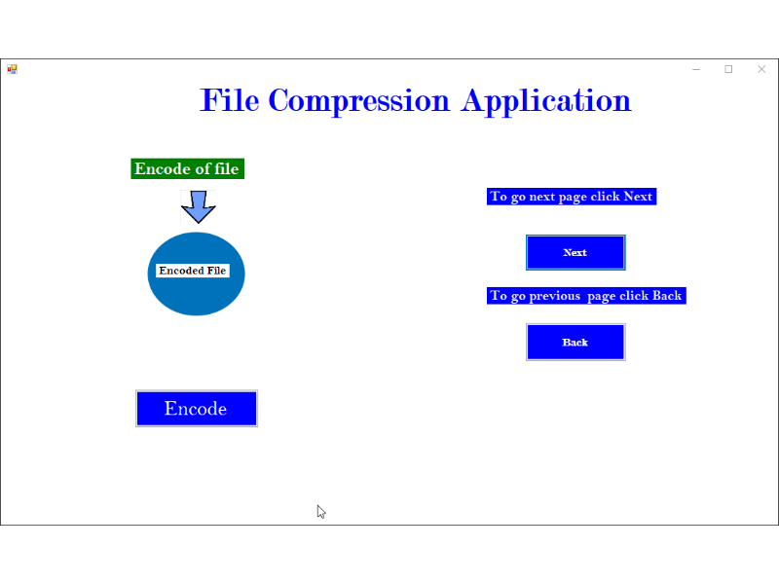

**Encode of file:**

**Description:**

In this interface file is encode by clicking on encode button encoding is a process of converting data from one form to other form .by encoding the file it can be save into more efficient compressed format.

1. **Step 5**

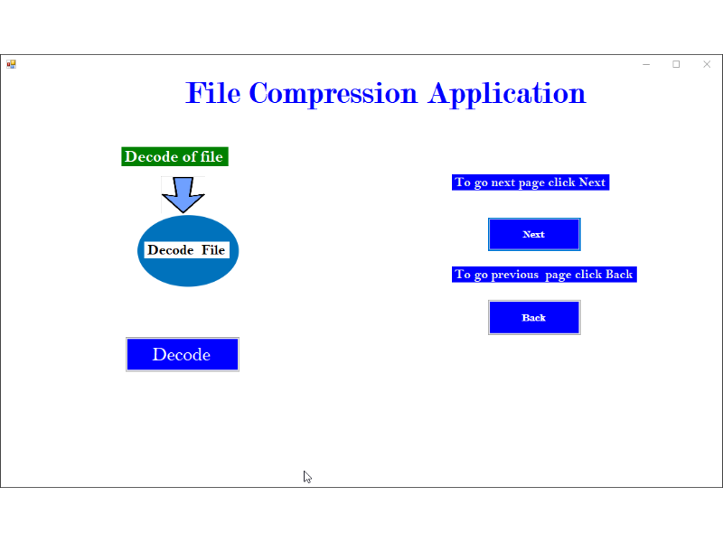

**Decode of file:**

**Description:**

In this interface file is decode by clicking on decode button. Decoded is opposite process it is conversion of encoded file into original file or sequence of character